Table :- Employee

insert into Employe values(103,"neha","E-101",1234567890,"neha@gmail.com",101),(104,'rahul','E-102',1234567890,'rahul@gmail.com',105);

insert into Employe values(105,"abhishek","E-101",5434567890,"abhishek@gmail.com",102);

mysql> UPDATE employe SET contactNo = 1234567890 WHERE contactNo = 54345690; Query OK,

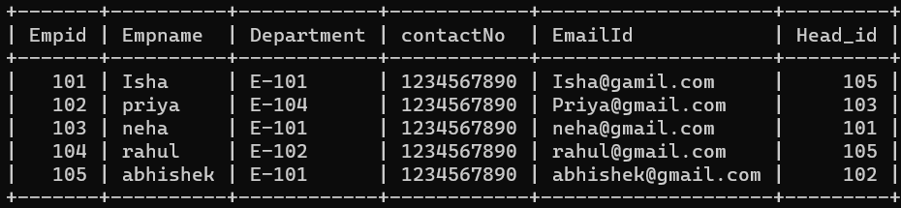

Table :- EmpDept

mysql> insert into EmpDept values('E-101','HR','Monday',105);

Query OK,

mysql> insert into EmpDept values('E-102','Development','Tuesday',101);

Query OK,

mysql> insert into EmpDept values('E-103','Hous Keeping','Saturday',103);

Query OK,

mysql> insert into EmpDept values('E-104','sales','Sunday',104);

Query OK,

mysql> insert into EmpDept values('E-105','Purchage','Tuesday',104);

Query OK,

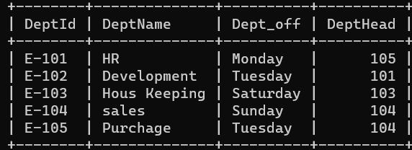

Table :- Emp Salary

mysql> create table Empsalary (EmpId int ,salary int , IsPermanent varchar(250));

mysql> desc Empsalary ;

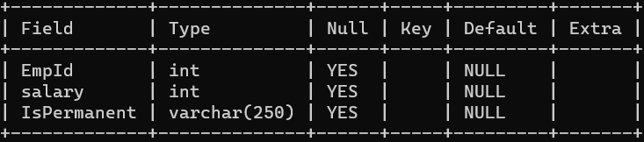

mysql> insert into Empsalary values (101,2000,'Yes');

mysql> insert into Empsalary values (102,10000,'Yes');

mysql> insert into Empsalary values (103,5000,'no');

mysql> insert into Empsalary values (104,1900,'Yes');

mysql> insert into Empsalary values (105,2300,'Yes');

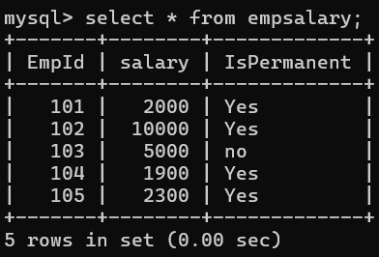

Table :-Project

mysql> create table project (projectId varchar(250),Duration int);

mysql> desc project ;

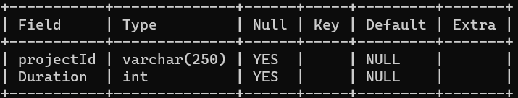

mysql> insert into project values ('p-1',23);

mysql> insert into project values ('p-2',15);

mysql> insert into project values ('p-3',45);

mysql> insert into project values ('p-4',2);

mysql> insert into project values ('p-5',30);

mysql> select * from project values;

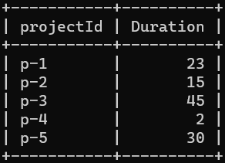

Table :- Country

create table country (cid varchar(50),cname varchar(50));

mysql> desc country ;

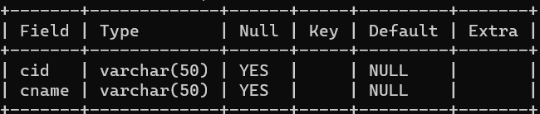

mysql> insert into country values ('c-1','india');

mysql> insert into country values ('c-2','USA');

mysql> insert into country values ('c-3','China');

mysql> insert into country values ('c-4','Pakistan');

mysql> insert into country values ('c-5','Russia');

mysql> select * from country;

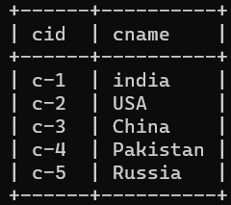

Table :- client Table

mysql> insert into clientTable values ('cl-1','ABC Group','c-1');

mysql> insert into clientTable values ('cl-2','PQR','c-1');

mysql> insert into clientTable values ('cl-3','XYZ','c-2');

mysql> insert into clientTable values ('cl-4','tech altum','c-3');

mysql> insert into clientTable values ('cl-5','mnp','c-5');

mysql> select * from clientTable;

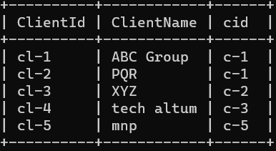

Table:- Empproject

mysql> create table Empproject(EmpId int, projectId varchar(250),clientId varchar(250),startYear int ,EndYear int);

mysql> desc Empproject;

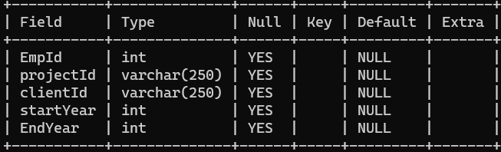

mysql> insert into Empproject values (101,'p-1','c1-1',2010,2010);

mysql> insert into Empproject values (102,'p-2','c1-2',2010,2012);

mysql> insert into Empproject values (103,'p-1','c1-3',2013, null);

mysql> insert into Empproject values (104,'p-4','c1-1',2014, 2015);

mysql> insert into Empproject values (105,'p-4','c1-5',2015, null);

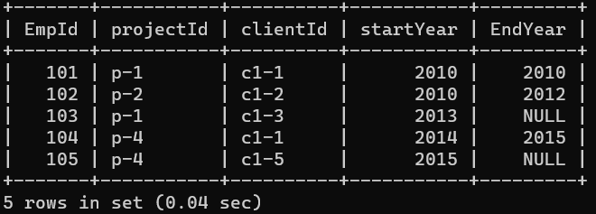

**Queries :-**

1) Select the detail of the employee whose name start with P

**Output :-**

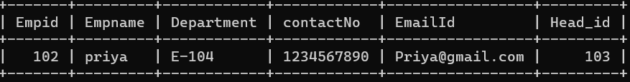

2) How many permanent candidate take salary more than 5000.

**Output :-**

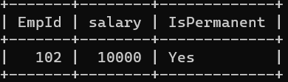

3) Select the detail of employee whose emailed is in Gmail.

**Output:-**

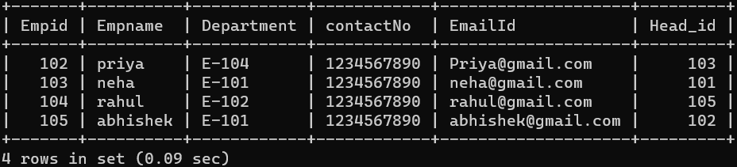

4) Select the details of the employee who work either for department E-104 or E-102.

**Output:-**

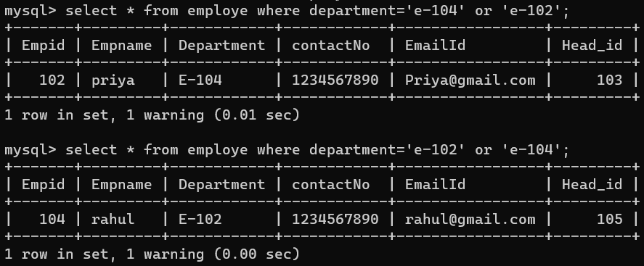

5) What is the department name for DeptID E-102?

**Output:-**

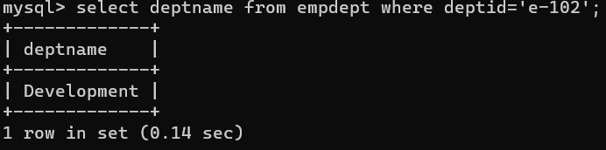

6) What is total salary that is paid to permanent employees?

**Output :-**

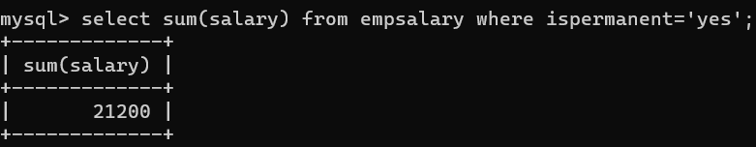

7) List name of all employees whose name ends with a.

**Output :-**

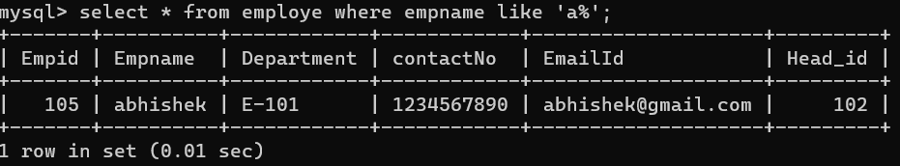

8) List the number of department of employees in each project

**Output:-**

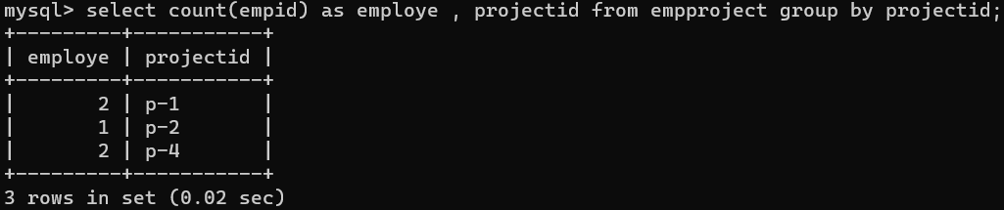

9) How many project started in year 2010.

**Output:-**

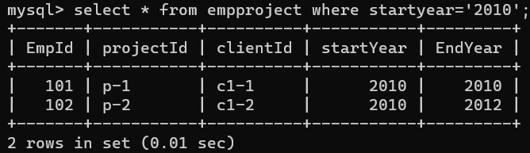

10) How many project started and finished in the same year.

**Output:-**

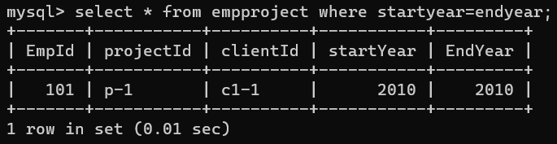

11) Select the name of the employee whose name's 3rd character is 'h'.

**Output:-**

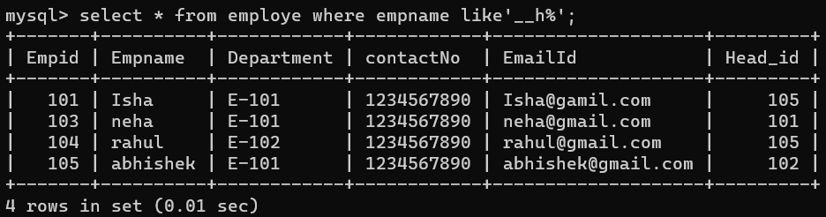

12) Select the department name of the company which is assigned to the employee whose employee id is grater 103.

**Output:-**

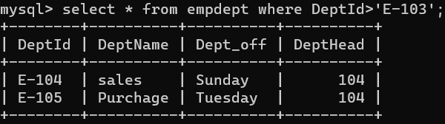

13) Select the name of the employee who is working under Abhishek.

**Output:-** 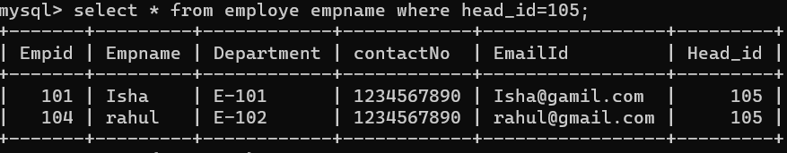

14) Select the name of the employee who is department head of HR.

**Output:-**

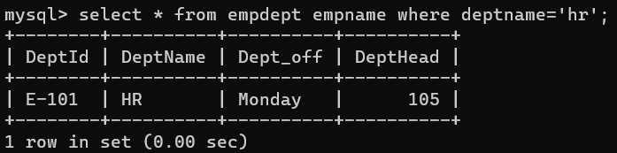

15) Select the name of the employee head who is permanent.

**Output:-** 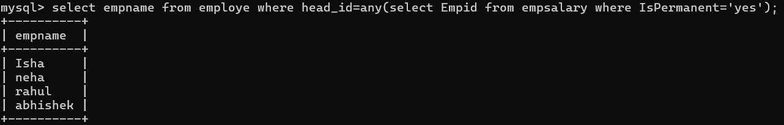

16) Select the name and email of the Dept Head who is not Permanent.

**Output:-** 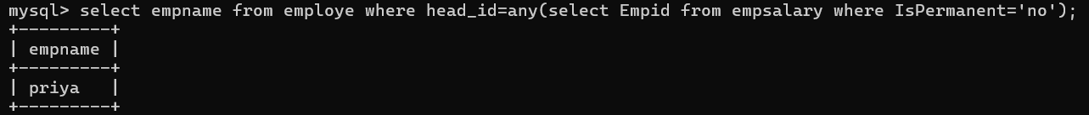

17) Select the employee whose department off is Monday

**Output:-** 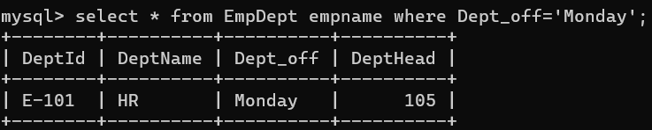

18) select the Indian clients details.

**Output:-**

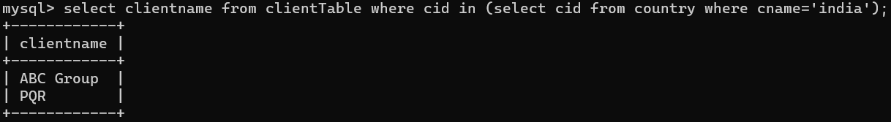

19) select the details of all employee working in development department

**Output:-**

